These iTunes Lab assignments will be turned in as PDF documents, one per day for Days 3-5 of ADB. Save a copy of this document, paste your answers in the marked areas, and generate a PDF when you are complete. Your PDF file name should have the following format, all lower-case:
yourname-itunes-1.pdf
All PDFs are to be committed to the /dbs_homeworks/ directory in source control before the beginning of the following class. Even though you must commit your homework before the start of class, you should not push your homework to Alfalfa until the beginning of class.
You will paste your answers in the marked areas, ensuring to preserve the “Answers” format for the entirety of your answer, so that it is visible like so:
SELECT a, b, c
FROM foo
Line breaks can be added within the Answers formatting by using Shift+Return instead of a normal Return.

Day 3: Normalization, Keys, Indexes, Joins
Due: Committed to source control before start of class, Day 4
When you use iTunes to browse through your music library, you are browsing through a database. We can think of your library as containing a number of tracks, each of which has an associated album, artist, genre, and other properties.
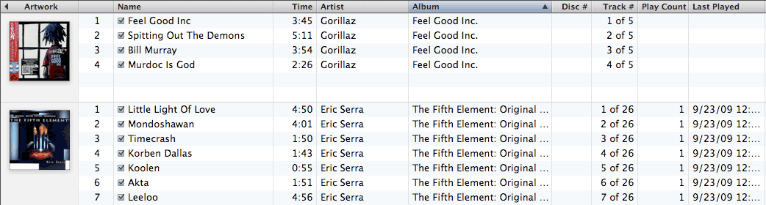
If you do not normally use iTunes to manage your music, you should take a moment to add a number of music files to your iTunes library. The more you add, the easier it will be to be sure that your queries are correct.
The iTunes database is in a proprietary binary format, but they also export a read-only XML file for other applications to interact with. Your iTunes file can be found by browsing from your home directory:
~/Music/iTunes/iTunes Music Library.xml
We need to import this file into mySQL, which means that we need it in a more mySQL-friendly format, such as comma-delimited CSV. I have created a script to convert your iTunes XML to CSV. Browse to this URL in your web browser:
http://66.192.104.111/~server_side_scripting/ASL/iTunes/itunes.cfm
At that page, you can upload your iTunes XML using a web form. You should get back an archive, iTunesTables.zip, containing two files. For now, only the iTunesMedia.csv file is of interest.
In the / dbs_homeworks / directory of source control, you should find a iTunesMedia-Table.sql file. This file contains the CREATE TABLE statement for an iTunesMedia table, into which you can import your iTunes library. However, as each user’s library is different, with different attributes completed or left empty, the library may not be a perfect match for this table structure.
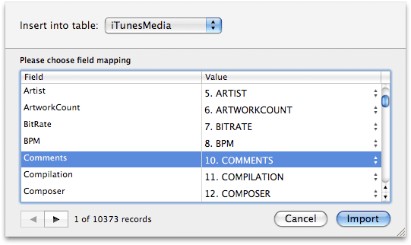
Your import in Sequel Pro will need to be adjusted to match the table columns to their library source, like the figure to the right.
This import step is very easy to accidentally get wrong, so you should browse the content of your table and be sure that all of the data went into the correct columns. If not, truncate your table and start again.
If we look at the content of the iTunesMedia table, we can see that it is extremely denormalized – mostly through repeated text data inviting update anomalies. Our first task will be to normalize this table, breaking it into several smaller tables.

Task 1: Normalization
When normalizing a large table such as this, we can come at it from two angles: we can think of the real-world model that our data represents, and we can look at the data to see where the repetition occurs. Both approaches will serve us here.
If we think about the real-world model that an iTunes Library represents, we know that our music is composed of Tracks. Those tracks are on Albums, which have Artists. Multiple tracks may be on an album, and an artist might release multiple albums. Each track has a Genre, such as Rock or Pop. Each track represents a file, which has a Kind, such as MP3, AAC, or MP4 Video. To keep things simple, we will associate artists directly with Tracks for now, so that we can accommodate albums with more than one artist.
We will take this normalization one extra step and split the track information into two tables, following what is called a Master-Detail pattern. One table will hold all of the vital information for each track, while another table will hold the ancillary (extra, possibly unneeded) information.
Visually, that produces a model that looks like this:
Artist |  | Track Master  Track Detail |  | Genre
Album |  | Track Master  Track Detail |  | Kind
We can verify this by inspecting how redundant our data is. Run the following query to get a count of all tracks.
SELECT COUNT(*) AS TrackCount
FROM iTunesMedia
Enter your track count:
Tracks:
We can find the number of different albums with the following query:
SELECT COUNT(DISTINCT Album) AS AlbumCount
FROM iTunesMedia;
Enter your album count:
Albums:
Modify the previous query to count the number of different artists, genres, and file kinds. Be sure to modify the column alias so that your result has a meaningful title.
SELECT ... | Artists:
SELECT ... | Genres:
SELECT ... | Kinds:
You should be able to see that the number of different artists and albums is only a fraction of the number of different tracks. This means that we have quite a bit of redundant data in these fields. Additionally, having the full artist, album, and genre names stores with the tracks is inviting update anomalies, as what happens if someone updates a track with “Vanilla Iec” instead of “Vanilla Ice”?
When breaking out column data into its own normalized table, our first question should be about keys: can we use a natural key, with data that has an inherent meaning, or do we need a surrogate key, such as an auto number, GUID, or hash? To answer this question, we need to go bck to the model.
For artists, albums, and genres, there are no good natural keys. That is, there’s no real-world value that can be used as a key that would function better than using the entire text string, which we don’t want to do. For those tables, we’ll use an autonumber for a key.
Create tables itm_artists, itm_albums, and itm_genres. Each table should have an autonumber for a primary key, named artistID, albumID, and genreID. Each table should also have the relevant text data: artistName, albumTitle, and genreTitle. The text fields should be wide enough to hold the largest entries in our database. We can check to see how much space we need, by looking for the longest string in each column, like so:
SELECT MAX(LENGTH(Artist)) AS Longest
FROM iTunesMedia;
It also makes sense to take the longest number for each, add in a bit of padding for future expansion, such as an extra 20% or so, and then round to the nearest 20. So, if your longest album title were 86 characters, you’d probably want to make your albumTitle column 100 or 120 characters wide.
Paste your CREATE TABLE statements for those three tables below. Be sure to include the primary keys in the statements.
CREATE TABLE itm_artists ...
CREATE TABLE itm_albums ...
CREATE TABLE itm_genres ...
Our table of file kinds presents us with an opportunity. We should only have a few kinds of files. A typical library may have MP3s, AACs, and maybe some video files. Since there are so few, we can pick our surrogate keys to be somewhat more meaningful than just autonumbers. Instead of an int type, let’s make our kindID primary key in our itm_kinds table a varchar(4). This is a common size for what we are doing, as four characters offers a variety of options while also being long enough to be meaningful without being so long as to be unwieldy. Our text field will be called kindTitle. Paste your CREATE TABLE statement below.
CREATE TABLE itm_kinds ...
We’re now left with only our track data to model. Since we want to follow a Master-Detail pattern, we will split the track data across two tables: itm_tracks and itm_tracks_detail. The master table should have only the primary and foreign keys and the data that is crucial to the track. In our real-world iTunes library, our only crucial track data is its title.
Create your itm_tracks table with the following columns: trackID, albumID, artistID, kindID, genreID, and trackTitle. The trackID is the primary key which iTunes provides for us in the form of a char(16) column. Find an appropriate length for your title column, and be sure to include the primary key in the statement. Don’t worry about foreign key references yet – we’ll add them later.
CREATE TABLE itm_tracks ...
Your detail table, itm_tracks_detail, will still need the proper primary key. Also add in columns for: playDate datetime, playCount int, bitrate int, addedDate datetime, fileSize int, duration int, rating int, releaseYear smallint, and skipCount int.
CREATE TABLE itm_tracks_detail ...

Task 2: Keys
Now that we have created all of our tables, we should complete our model by relating the tables to each other with primary and foreign keys. Remember that in mySQL, only the InnoDB engine can use foreign keys correctly. Go back and check your table to ensure that they are all using the InooDB engine.
We’ve already identified the primary keys for each table as part of the normalization process. You should have a total of 5 foreign keys: 4 from itm_tracks, and one from itm_tracks_detail. You should set the correct update and delete cascade settings for each key to ensure data integrity. Paste them below.
ALTER TABLE ...
ALTER TABLE ...
ALTER TABLE ...
ALTER TABLE ...
ALTER TABLE ...

Task 3: Indexes
By normalizing our artists, albums, genres, and file kinds into tables with just a surrogate key and a text field, we’ve followed a common design pattern to create what are called Lookup Tables, and a schema that is called a Star Schema, so named because the lookup tables fan out from the central table like a star. In a Star schema, the central table with all of the interesting information is called the Fact table, and in our model that table is the itm_tracks table.
Because real-world usage has us commonly searching on the text values in lookup tables, creating them is good for normalization and integrity, but potentially bad for real-world performance. Indexes can help us reduce this tradeoff by making searches on these text fields faster. Since we must use InnoDB to get the benefit of foreign keys, we cannot use FullText indexes as we could with myISAM. Still, the performance increase of even a normal index is worth the time to create them.
For each of your lookup tables, create a unique index on the text field and paste the statements below.
CREATE UNIQUE INDEX ...
CREATE UNIQUE INDEX ...
CREATE UNIQUE INDEX ...
CREATE UNIQUE INDEX ...
When you create your indexes you should notice that mySQL has already created some indexes for you. Those indexes correspond to the keys you have created. Primary keys are a kind of unique index, while foreign keys are a kind of non-unique index.

Task 4: Migrate Your Data
We will need to populate our lookup tables before we can populate our fact (track) tables. Since we’re using autonumbers, populating the artists, albums, and genres is easy: we need to get the distinct values for each and let mySQL do the rest. We can get the distinct artists like so:
SELECT DISTINCT Artist
FROM iTunesMedia
WHERE (Artist <> '')
ORDER BY Artist;
You should notice that we have an extra WHERE clause to filter out artists that are blank. We don’t need a blank entry for empty artists, so we throw it away.
We can turn this query into an INSERT statement by adding a clause to it:
INSERT INTO itm_artists (artistName)
SELECT DISTINCT Artist ...
If an insert like this does not work for you, it might be because you get an error about duplicate keys. This would mean that you have an artist with a variation on capitalization, such as ‘Vanilla Ice’ and ‘VANILLA ICE’. You will need to go into your iTunesMedia table and correct these problems before your insert will work.
Repeat this procedure for albums and genres and paste your statements here:
INSERT INTO itm_albums ...
INSERT INTO itm_genres ...
As we used a text-based key for our file kinds instead of an autonumber, we have to do something a little different. We have a chicken-and-egg problem: we can’t make up human-readable keys until we can see the data in the table, but we can’t see the data in the table until we have unique keys! For now, let’s cheat:
SELECT DISTINCT RIGHT(MD5(Kind),4) AS kindID, Kind
FROM iTunesMedia ...
Remember that the MD5() function in mySQL creates a hash of a string. We’re hashing the name of the file kind, then just grabbing the right-most 4 characters of that hash with the RIGHT() function. Since hashes are very unique, we can be mostly certain that this will not produce duplicates. Alter this statement to an insert:
INSERT INTO itm_kinds ...
Run the insert and see if it works. When it does, you can go into the table content and give each file kind a more meaningful key. I’ve used the following conversion table, and if you use the same table it’ll help you follow along.
kindID | kindTitle
AAC | AAC audio file
MP3 | MPEG audio file
M4V | MPEG-4 video file
EAAC | Protected AAC audio file
MAAC | Purchased AAC audio file
MM4V | Purchased MPEG-4 video file
MOOV | QuickTime movie file
WAV | WAV audio file
AIFF | AIFF audio file
With our lookup tables complete, we can now fill in the missing data for our fact (tracks) table. We will need to pull the track title (Name) from the iTunesMedia table, joined to our artists, albums, genres, and file kinds tables based on the appropriate text fields in each. The PersistentID in our iTunesMedia table will become our trackID. Paste your insert statement below.
INSERT INTO itm_tracks ...
Similarly, we’ll need to insert the relevant data into our tracks detail table. As there are no foreign keys here, we need only to select the PersistentID as the trackID again, and then match up the remaining relevant columns.
INSERT INTO itm_tracks_detail ...

Task 5: Complete Day 3
Go over your schema to make sure that your data type choices make sense, your tables all have the appropriate keys, and that you have useful indexes. When you are satisfied with your schema, export your itm_* tables to a SQL dump file and check it into source control in the /sql/ folder with a yourname-itunes.sql file name. Do not include your iTunesMedia table in the dump – only the structure and data of your normalized tables.
Export this file, with your answers in the correct areas, as a PDF and commit it to source control in the / dbs_homeworks / folder with a yourname-itunes.pdf file name. Do not push the file until you arrive in class on Day 4.

While in the real world there may be more than one artist with the same name, our iTunes library is not going to be concerned with that distinction.

